Influence of maladaptive migrants on a dying population

Florin Suter, Balz Fuchs, Felix Rentschler

**Abstract**

Evolutionary rescue is a process, in which doomed populations might avoid extinction through adaption by natural selection (Bell, 2017; Gomulkiewicz et al. 1995). Consider a scenario where a threatened population could adapt through a single beneficial mutation yet faces geneflow from migrants carrying the maladaptive genotype. How are the migrants influencing the extinction-probability and how big is the probability of rescue for the doomed population under these circumstances? After we programmed our model and gathered a lot of data, we found, that only under low migration the population would get rescued, under medium migration extinction probability is highest and with high migration the population is able to persist a certain level. Note that we chose the mean migrants per generation between 0-10 and got such different results. This leads to the conclusion, that doomed populations are very sensitive and even the smallest changes can have a drastic impact.

**Introduction**

In conservation we often see the introduction of migrants as a way to save a doomed population (Alexander et al. 2014). There are many examples of this such as the rescue of the Florida panther (*Puma concolor coryi*) population by introducing panthers from other regions to increase the populations gene pool, thus rescuing them from inbreeding depression (Pimm et al. 2006).

However, in this model we thought about a diploid population (aa) that is maladapted to its environment and can only become a growing population by acquiring a certain beneficial recessive mutation (AA). Note that usually recessive alleles are referred to with a small letter but here the dominant allele is called “a” and the recessive allele “A”. Our hypothetical scientists are attempting to save the population by introducing migrants from a source population in which the beneficial allele is not present. As such, these migrants are maladaptive. In our model we hoped to see the impact of a migrating deleterious genotype on the extinction and rescue probabilities of our population. So, we formulated these two biological questions:

* How does migration of a deleterious genotype influence extinction probability of a diploid population?
* How big is the probability for a diploid population to be rescued with migration of a maladaptive genotype?

We hypothesized that the probability of rescue would be higher under low and high levels of migration compared to moderate levels, and vice versa for the extinction-probability. We thought that a small number of migrants would still lead to evolutionary rescue. But even slight increases in this number would lead to too many individuals with maladapted genotypes per generation, so that the mutants cannot take over and the population would die out. However, high migration numbers/generation could stabilize the population and increase the chance of evolutionary rescue again. This hypothesis would show a contrasting result to the model Uecker et al. developed in 2013, this could be feasible, because contrasting to our model they used migrants with the beneficial genotype.

**Methods**

For this model all coding was done using the language r. For the code base r was sufficient however for the visualization of the results packages such as ggplot were used to increase legibility.

Source code

The base source code used for the further coding of the model was provided by the theoretical ecology and evolution (TEE) research group. The code models a doomed population that will go extinct but can be rescued by the fixation of a beneficial mutation. It simulates this for as many generations as are input. The source code can be found on the TEE Teams platform. The rest of the code was written by us.

Simulation of one generation

Parameters:

N_aa = 1000

N_Aa = 0

N_AA = 0

Fitnessaa = 0.9

FitnessAa = 0.9

FitnessAA = 1.1

Avgmigrants = 0,1,2,3,4,5,6,7,8,9,10

Mut_rate = 0.0005

In a first step one generation has to be simulated. As the population is diploid there are three starting populations that are set as N_aa = 1000, N_Aa = 0, and N_AA = 0. As there is a fitness difference between the different genotypes these had to be defined as well. For the fitness of the different genotypes, we chose fitnessaa = 0.9, fiitnessAa = 0.9, and fitnessAA = 1.1. Both the selection coefficient and the decay rate are contained in the fitnesses in order to keep the number of parameters to a minimum. The next parameter is avgmigrants. This parameter represents the mean number of migrants that enter the system in the given generation. Here it is important to note that this is the parameter that is varied. We tested the model with zero to ten migrants. The genotype of these migrants is always the maladaptive aa genotype. The final parameter defined for this function is the mutation rate mut_rate = 0.0005. This mutation rate was chosen arbitrarily in a way that the average number of mutants per generation isn’t larger than one.

The function assumes a Hardy-Weinberg equilibrium. The parts of the code dealing with this will be described below. Some variables are mentioned below and are not explained. For these please see the code provided in the attachment.

1. The total number of a and A alleles are calculated:
$$a_tot = 2*N_aa+N_Aa$$

$$A_tot = 2*N_AA+N_Aa$$

2. Number of mutations from A to a and back are calculated:
$$a_to_A_mut = min(rpois(1,a_tot*mut_rate),a_tot)$$

$$A_to_a_mut = min(rpois(1,A_tot*mut_rate),a_tot)$$

3. p and q are defined as:
$$p = \frac{(a_tot+A_to_a_mut-a_to_A_mut)}{(2*tot_pop)}$$

$$q = 1-p$$

4. Calculate frequency of the genotypes in the next generation. This is where selection takes place
$$det_aa_next = (p^2)*fitnessaa/avg_fit$$

5. Draw the true number of offspring. The number stored in next_gen_tot_pop is the deterministically calculated population size for the next generation. Note that migrants are only added to the aa offspring as this is the maladaptive genotype.

$$offsp_aa = rpois(1, next_gen_tot_pop*det_aa_next) + aa_migrants$$

$$offsp_Aa = rpois(1, next_gen_tot_pop*det_Aa_next)$$

$$offsp_AA = rpois(1, next_gen_tot_pop*det_AA_next)$$

Simulation of population until one of three conditions is reached

Parameters:

N_init_aa = 1000

N_init _Aa = 0

N_init _AA = 0

Fitnessaa = 0.9

FitnessAa = 0.9

FitnessAA = 1.1

Avgmigrants = 0,1,2,3,4,5,6,7,8,9,10

Mut_rate = 0.0005

T_max = 10’000

Here the code is run until one of three conditions is reached. The first condition is that the population reaches 1.5 times its starting size. This is seen as successfully escaping extinction and becoming a growing, self-sustaining population. The second condition is that the population goes extinct. As a population with a continuous stream of incoming migrants never stays at zero individuals for long, extinction is defined as 2* the number of migrants per generation. The final condition that can be reached is that the population surpasses t_max = 10000 generations. This is a fail-safe that ensures that the simulation stops at some point and does not run indefinitely.

This function contains most of the same parameters as the function explained above. As this function runs for more than just one generation the labels for N_aa, N_Aa, and N_AA have been changed to N_init_aa, N_init_Aa, and N_init_AA. The only new parameter is the aforementioned t_max which represents the maximum number of generations that the model should simulate. The important steps of the function will once again be outlined below. As before some steps will be left out and can be found down below in the attachment.

1. The for-loop runs for t_max generations generating t_max generations which are continuously added to one matrix: pop_vector.
2. Next we have an if command. This loop breaks off the simulation if a population size is generated, that is more than 1.5*N_init.
3. The final else if command breaks of the simulation if the minimal populations size goes below the threshold of 2*avgmigrants at which point the population is assumed to be functionally extinct.
4. When the function breaks down, a value of 1,2 or 3 will be put at the end, to signal how the for loop was ended.

To analyze the influence of migration on the outcome we simulated the population for each migration (0, 1, 2, ..., 9, 10) value 2’000 times. To compare our results with dominant or heterozygote intermediate mutations we also simulated these 2’000 times for each migration value. Because we inspected something strange at around 5 migrants per generation, we repeated the simulations of 3 to 7 migrants per generation another 10’000 times.

For the visualization of the outcomes bar plots and violin plots were used. One of the advantages of using violin plots is that they allow the visualization of the density of the values. This can help the understanding of the distribution of the data as is the case in this figure.

**Results**

As a reminder we will reiterate our biological questions:

1. How does migration of a deleterious genotype influence extinction probability of a diploid population?

2. How big is the probability for a diploid population to be rescued under the influence of the migration of a maladaptive genotype?

The first graph (*Figure 1, left*) already gives a lot of information to answer these questions. As mentioned in the methods section the graph depicts the proportion of runs that reached each of the three break-off states for 0-10 migrants. As can be seen in the graph on the left, the probability of the population being rescued (the mutant genotype taking over) is very low and only seems to happen with any consistency at very low levels of migration. To show the true extent of rescue we decided to extract the rescued populations and visualize these in a second graph (*Figure 1, right*). As is made clear, the percentage of rescued populations is very small at low migration levels and nonexistent in populations that experience on average more than seven migrants.

In *Figure 1* we noticed an interesting pattern. The rescue probability seems to rise slightly around five migrants. Although the chances of this being a meaningful pattern seemed quite small because only 8 populations reached the maximum (which could be due to chance), we decided to test this phenomenon. To do so the simulation was rerun and only the outputs for 3-7 migrants per generation were graphed. As is made clear by the graph there is probably no causation for the slight increase in rescue probability seen above except for stochasticity (*Figure 2*).

As *Figure 1* shows, the populations, especially at high migration rates, never reach extinction or carrying capacity. This led us to believe that these populations are so called sink populations that are only viable because of the incoming migrants. An interesting thing to study in this regard is the size of these populations. As we defined extinction as 2 * mean migrants per generation we created a graph to show us how much above the extinction threshold (red line) the populations lie. As can be seen in the graph (*Figure 3*), the population sizes are very variable at low migration rates, the final population sizes lie either below or at the extinction threshold or at the defined maximum. As the number of migrants increases, the spread of population sizes becomes much more uniform as the average population size starts to hover around 100 individuals.

As we were interested in a diploid population, we wanted to visualize the allele frequencies in the populations (*Figure 4*). This allowed us to see if the populations allowed for any real presence of the mutant allele or if it couldn’t really find any purchase in the populations. The graph only shows the allele frequencies of the populations that had a final population size >0. As can be seen in the graph, the populations with no migrants are made up of entirely mutant alleles. As we start to introduce migrants it becomes clear that the distribution of alleles is a lot more varied. As the migration reaches the critical amounts of 8-10, we see the that the mutant allele can never really find any purchase. However, it is also never completely eradicated.

Our model also allowed us to generate a graph with the generation at which the maximum was reached (*Figure 5*). It is important to note that this graph only goes up to 7 migrants per generation because after that, no more generations reach the maximum. The time to maximum increases with incoming migrants. This shows that the migration of the dominant, deleterious genotype is bad for the rescue of the population.

We didn’t just simulate the scenario with a recessive mutation, but also with heterozygote intermediate and a dominant mutation.

In both cases we see a large increase in the number of populations that reached the maximum population size (*Figure 6*). The populations that reach t_max that were so prevalent in our original model (*Figure 1*) have completely disappeared.

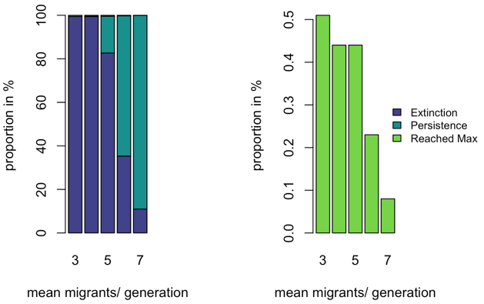

Figure 2: Same graphs as figure 1 but with only migrants 2-7. Here we simulated 10’000 repetitions. Redoing these graphs allows us to discard the idea that the number of populations that reaches rescue increases again around 5 migrants per generation

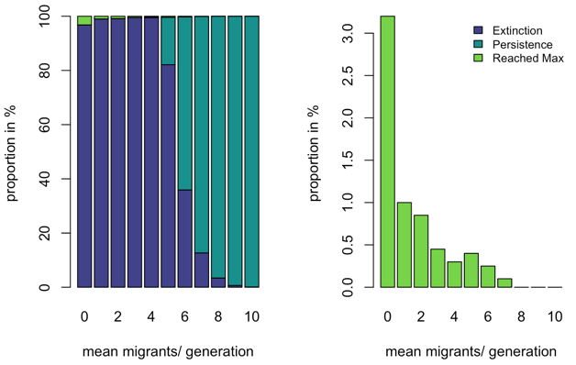

Figure 1: The graph (left) shows the relative number of simulated populations that reached each of the three predefined conclusions. The graph on the right highlights the percentage of populations for each number of migrants that reached rescue. This graph show that rescue is possible at low migration rates but declines drastically with the number of incoming migrants.

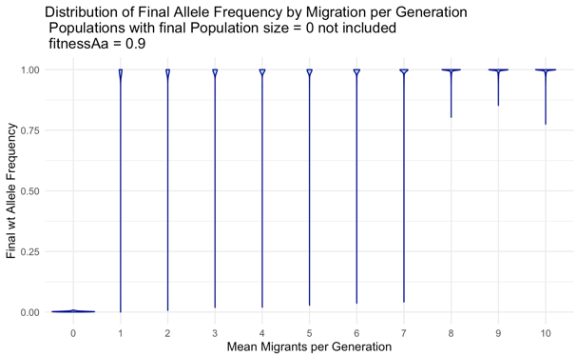

Figure 4: Distribution of final allele frequencies by migration per generation excluding populations with a final population size of 0. Density of datapoints is indicated by the horizontal width of the blue strip. At 0 migrants the only way the population can survive is if the mutant gene takes over while at larger migration rates, the mutation becomes rare and rarer. Interestingly, it hovers around 15% at very high migration rates and doesn’t go above that.

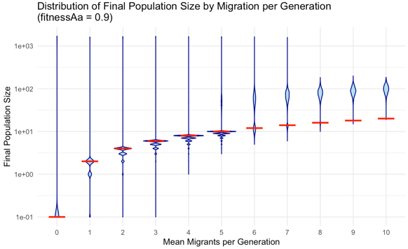

Figure 3: Distribution of the final populations size by migration per generation. The y axis is on log (10) scale. The red line denotes the threshold under which a population was considered extinct. The data is shown in a violin plot which shows the density of points as bulges. Here we can see that most populations at low migration levels go extinct with some reaching the maximum while at high migration levels most populations hover at around 100 individuals (which is above the extinction threshold).

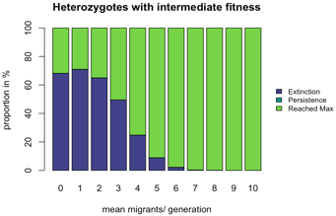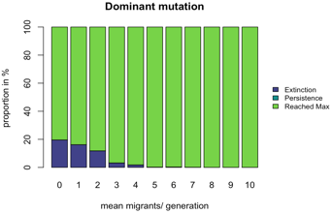

Figure 6: The model with heterozygotes with intermediate fitness (top) and the model with the mutation being dominant (bottom). All other parameters stay the same. In these two graphs we see that the probability for a population with a dominant mutation or a heterozygote with an intermediate fitness to reach the maximum is way higher.

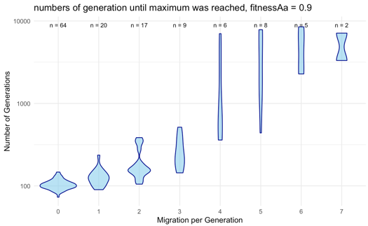

Figure 5: Number of generations until maximum is reached for 0-7 migrants per generation. As this is a violin plot, we can once again see the density of the datapoints. On top of each data distribution there is indicated how many datapoints where considered. At low numbers of migrants, the maximum is reached fairly early on and all populations reach the maximum after roughly the same number of generations. At higher migration rates the violin is more linear and has less of a bulge. This indicates that the possibility of the population to reach the maximum is random.

**Discussion**

Now we get to the discussion. A very interesting finding is that the rescue probability decreased with more migrants per generation. This can be explained because in our parameter range the populations must mutate to get rescued. We hypothesize that the mutant allele fails to increase because it never reaches a high enough frequency for its fitness advantage to drive its frequency higher in the next generation. This functions as followed:

$$q'=\frac{q^{2}⋅w_{AA}+pq⋅w_{Aa}}{\overline{w}}$$

$q^{'}=$ Next generation allele frequency

$w=$ Fitness of the genotypes

$\overline{w} =$ Average fitness

$q =$ Allele frequency mutant

$p =$ Allele frequency wt

If the change in allele frequency ($q’-q$) is not high enough, the immigration of individuals with wildtype genotypes (aa) will be able to set mutant allele frequency $(q)$ back to the same or lower allele frequency. The effective allele frequency of the mutant allele $({q'}_{e})$ is therefore influenced by the number of migrants, that got in:

$${q'}_{e}=\frac{q^{'}}{q^{'}+p^{'}+\frac{migrants}{population size}}$$

$migrants =$ Number of migrants that entered the population

$population size =$ Population size in this generation (migrants are included!)

This formula shows that the effective next generation allele frequency of the mutant allele is negatively influenced by migrants.

Further it was shown that populations which receive more than eight migrants per generation rarely go extinct. This is expected because firstly our extinction threshold is set arbitrarily and secondly because the defined decay rate is 0.1 and this decay can be compensated when 10% of the population size is equal to the number of migrants entering. Therefore, the system fluctuates around a dynamic stable state with a population size of:

$$population size= migrants per generation * 10$$

This also leads to the assumption that the population could be rescued with way higher migration even when the mutation will not take over. This would be around:

$$Migrants for rescue =\frac{ rescue threshold}{10}$$

It was very surprising to us how much of a difference it made to the outcome to have the heterozygotes have an intermediate fitness. The reason for this is that there is selection towards the heterozygote, not only the homozygote which is frequency dependent and mostly only occurs at higher allele frequencies.

**Conclusion**

Our results showed certain differences to our hypotheses. While we predicted that there would not be large differences in rescue probabilities between low and high migration-rates, the results showed that evolutionary rescue is only possible at very low migration-rates but even then, very unlikely. Populations with high migration-rates stabilize but are no longer rescued or go extinct. That an intermediate migration-rate increases the probability of extinction and makes evolutionary rescue very unlikely was confirmed by the results.

From our results we deduce, that if you want to start conservation actions on a population that is decaying with the wildtype phenotype and possible rescue mutation that is recessive, the migration from a wildtype population to this population should be limited, to ensure an evolutionary rescue.

**Limitations**

We are aware that we are in a very small niche with this model, of course it makes more sense for conservation actions to let individuals migrate because usually the potential evolutionary rescue mutation is not known and, for heritability modes other than a recessive mutation, rescue tendes to increase with increasing migrants. Also, the risk is probably lower because, as we have seen, small differences in the migration-rates in our model can greatly increase the extinction-probability for the population. We also focus here on fixed fitness numbers and thus never change the decay rate. We also don't know what the whole thing would look like if we were to add a carrying capacity.

**Literature**

Alexander HK, Martin G, Martin OY, Bonhoeffer S;  2014; Evolutionary rescue: linking theory for conservation and medicine.

S. L. Pimm, L. Dollar, O. L. Bass Jr; 2006; The genetic rescue of the Florida panther

Graham Bell; 2017; Evolutionary Rescue

Richard Gomulkiewicz, David Houle. 1995. Demographic and Genetic Constraints on Evolution

Hildegard Uecker, Sarah P. Otto, Joachim Hermisson; 2013; Evolutionary Rescue in Structured Populations

**Author contributions**

Data conceived and analyzed by: Florin Suter, Balz Fuchs, Felix Rentschler

Contributed data or analysis tools: Prof. Dr. Claudia Bank, Dr. Catalina Chaparro Pedraza, Dr. Loïc Marrec, Florin Suter, Balz Fuchs, Felix Rentschler

Performed the analysis: Florin Suter, Balz Fuchs, Felix Rentschler

Wrote the paper: Florin Suter, Balz Fuchs, Felix Rentschler